Bus Reservation System

Submitted as Mini Project for Special Topics: Programming with C++ Semester III
BACHELOR OF TECHNOLOGY
in
Computer Science and Engineering

Student Name 1
SRN:-PES1201701725
Student Name2
SRN:-PES1201700132

Under Guidance of
Prof. Jamuna S Murthy
BE (CSE), M.Tech (SSE)
Assistant Professor
Aug 2018- Dec 2018
Department of Computer Science and Engineering
PES UNIVERSITY
Outer Ring Rd, Banashankari 3rd Stage, Banashankari, Bengaluru, Karnataka 560085
www.pes.edu

The project is basically about Reservation system of bus.
It has five options like :
- Installing the bus
- Reserve the seat
- show about the bus
- buses available
- exit

INSTALLING:→

Here in this function we can install buses . Which has a features like
- bus number
- driver name
- timings
- from
- To etc…

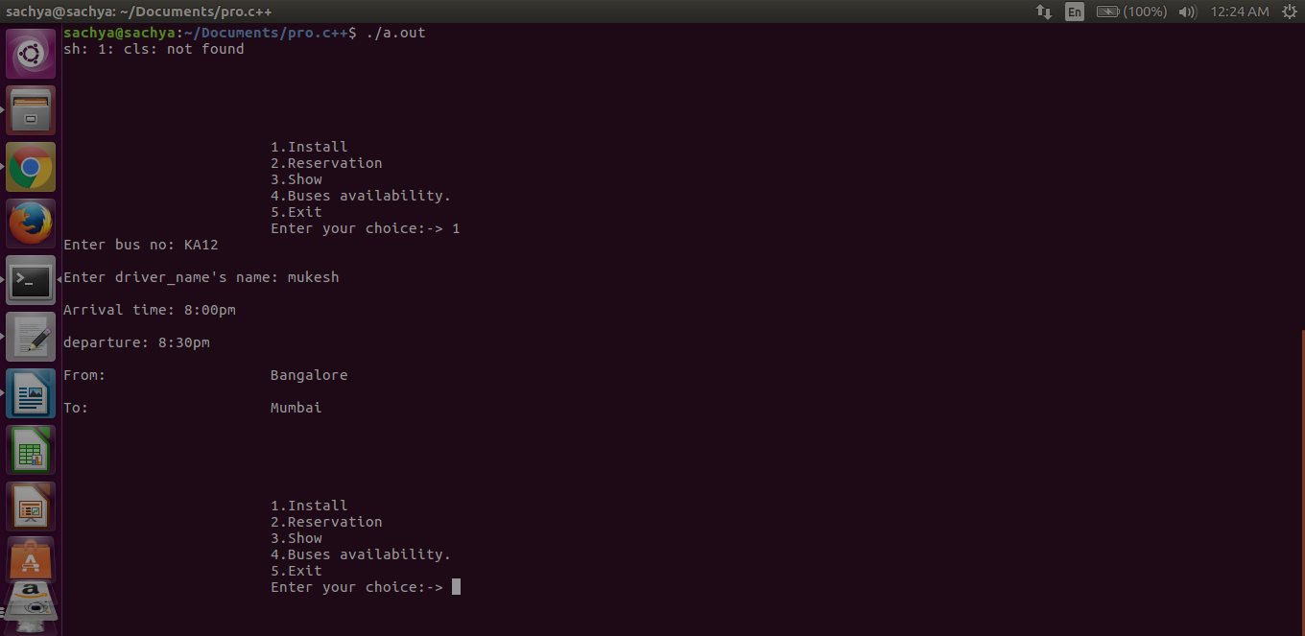

RESERVATION:→

Here user can reserve their seats . They are asked to enter bus number from which they wanted to travel. And there personal information Is asked . And then conform seat.

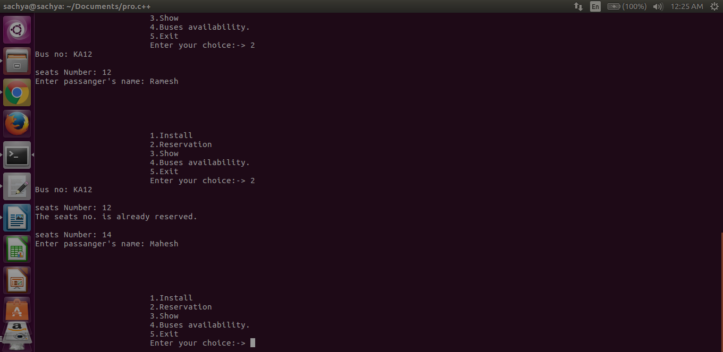

SHOW:→

It ask user to enter the bus number and give all the information about that bus.
Like about timings and all things about bus
And how many seats are booked .which all are empty
Who booked which seats etc…

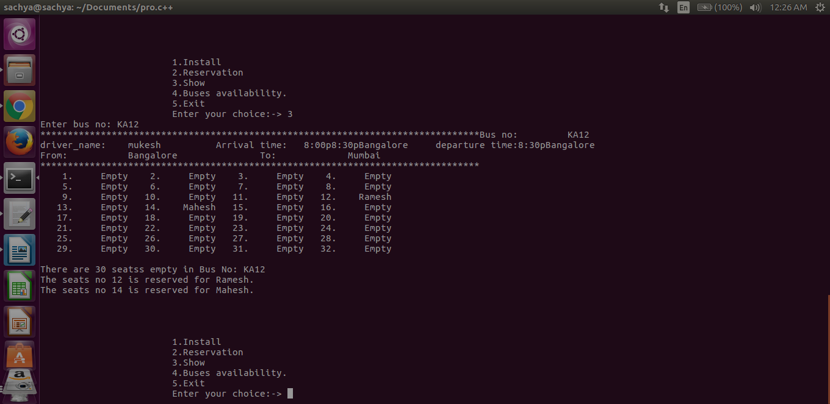

AVAILABILITY:→

It will give the information about the which all buses are available now . And also gives the all information about those buses ..

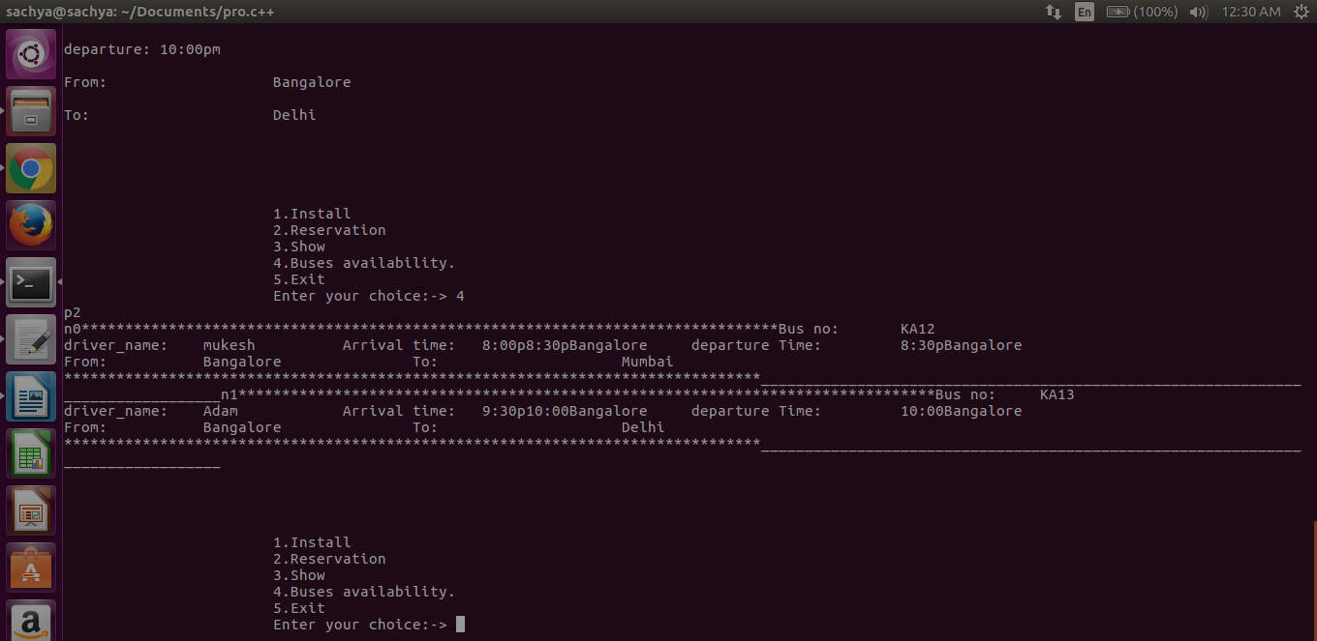

EXIT:→

If you select the exit then it bring you out of program .
Means takes you out of all operations.

